**Project Name: Searching for a Specific User and Updating the User Information**

**Developer Name:** Kapil Davey

**GitHub Link:**

**Output:**

**Create a JSP page to take in a user ID:**

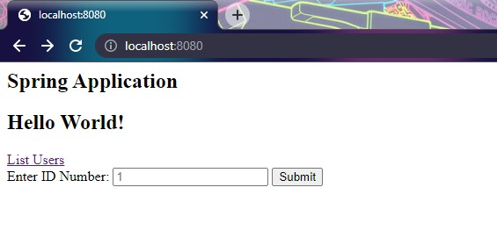

**Create a controller that will validate the user ID:**

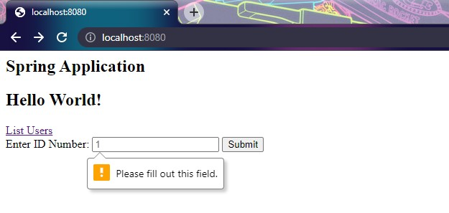

**If it is valid, it will retrieve user details from the database and show an edit form in JSP:**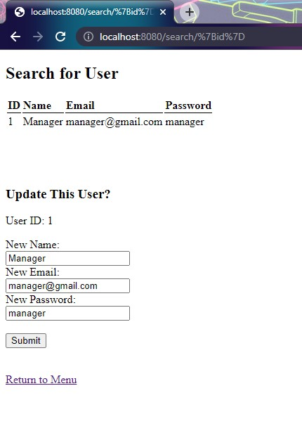

**Once the edit form is submitted, the controller will update the details in the database. A confirmation JSP page will be shown:**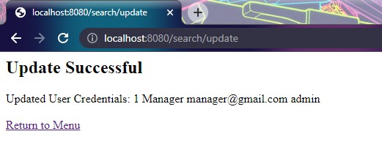

**If it is invalid, it will display a JSP page with an error message:**

